NEUROCODE

IF ELSE - ARITHMETIC, LOGIC, COMPARISON OPERATORS

Links:

Livestream: <https://youtube.com/live/gxI8vF7agYo>

W3School operators: <https://www.w3schools.com/cpp/cpp_operators.asp>

Long Division website for understanding % operator:

<https://www.calculatorsoup.com/calculators/math/longdivision.php>

1. **Understanding comparison operators(detail in livestream)**

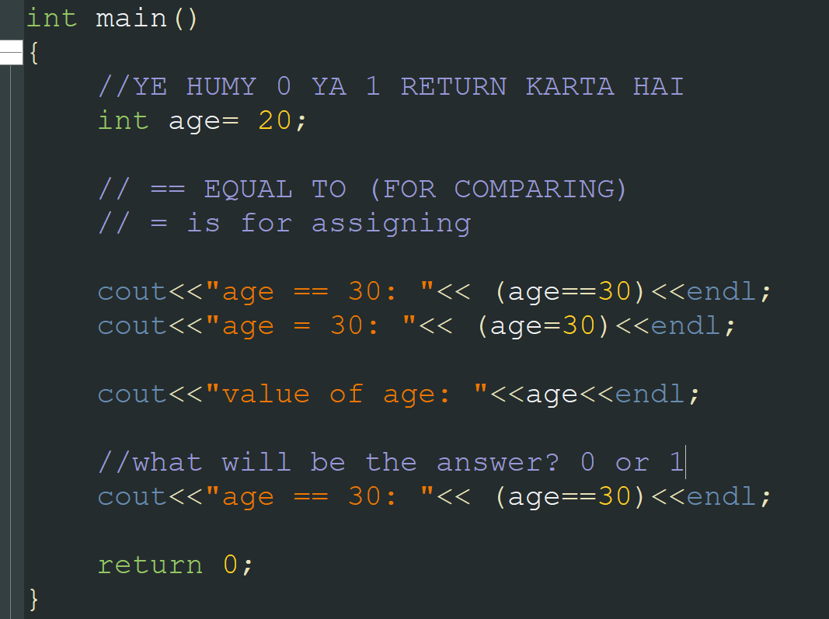

IF STATEMENT

Program 1.

1. #include <iostream>
2. using namespace std;
3. int main()
4. {
5. //write a program to tell if a number entered by
6. // user is 10 or if it is 20 or if it is
7. // any other number
8. int num;
9. cout<<"Enter a number: ";
10. cin>>num;
11. if( num == 10 )
12. {
13. cout<<"you entered 10"<<endl;
14. }
15. else if(num == 20)
16. {
17. cout<<"You entered 20"<<endl;
18. }
19. else
20. {
21. cout<<"You entered any other number than 10 and 20"<<endl;
22. }
23. return 0;
24. }

Program 2.

1. #include <iostream>
2. using namespace std;
3. int main()
4. {
5. //write a program to check which number is greater!
6. int num1,num2;
7. num1 = 20;
8. num2 = 50;
9. if( num1 >= num2)
10. {
11. cout<<"Num1 is greater!"<<endl;
12. }
13. else
14. {
15. cout<<"Num2 is greater!"<<endl;
16. }
17. return 0;
18. }

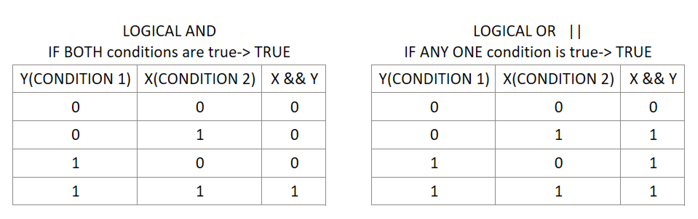

Program 3.

1. #include <iostream>
2. using namespace std;
3. int main()
4. {
5. //WE HAVE TO CHECK MULTIPLE CONDITIONS IN SINGLE IF
6. //write a program to check which number is greater!
7. int num1,num2;
8. num1 = 20;
9. num2 = 30;
10. // 0 || 0
11. if( (num1 >= num2) || (num1 >= 50) )
12. {
13. cout<<"Num1 is greater than num2 or >=50!"<<endl;
14. }
15. else
16. {
17. cout<<"Num2 is greater!"<<endl;
18. }
19. return 0;
20. }

Program 4. CALCULATOR

1. #include <iostream>
2. using namespace std;
3. int main()
4. {
5. //CALCULATOR
6. // + - * /
7. float num1,num2;
8. cout<<"Enter num1: ";
9. cin>>num1;
10. cout<<"Enter num2: ";
11. cin>>num2;
12. char op;
13. cout<<"ENter +, -, *, / : ";
14. cin>> op;
15. if(op == '+')
16. {
17. cout<< num1+num2;
18. }
19. else if(op == '-')
20. {
21. cout<< num1 - num2;
22. }
23. else if(op == '*')
24. {
25. cout<< num1*num2;
26. }
27. else if(op == '/')
28. {
29. cout<< num1/num2;
30. }
31. else
32. {
33. cout<<"you entered invalid operator!"<<endl;
34. }
35. return 0;
36. }

Program 5. EVEN ODD Number

1. #include <iostream>
2. using namespace std;
3. int main()
4. {
5. //PROGRAM FOR EVEN NUMBER
6. int num = 169;
7. if(num % 2 == 0)
8. {
9. cout<<"Even number!"<<endl;
10. }
11. else
12. {
13. cout<<"Odd number!"<<endl;
14. }
15. return 0;
16. }

Program 6. Take length and width of rectangle and check if it is a square

1. #include <iostream>
2. using namespace std;
3. int main()
4. {
5. int len,wid;
6. cout<<"Enter length:" ;
7. cin>>len;
8. cout<<"Enter width: ";
9. cin>>wid;
10. if(len == wid)
11. {
12. cout<<"IT is a square! "<<endl;
13. }
14. else
15. {
16. cout<<"it is not square";
17. }
18. return 0;
19. }

Program 7. Grade calculator

1. #include <iostream>
2. using namespace std;
3. int main()
4. {
5. //GRADE SYSTEM
6. // 80+ A
7. // 60-79 B
8. // 50-59 C
9. // <50 F
10. int marks;
11. cout<<"Enter your marks: ";
12. cin>>marks;
13. if(marks >= 80)
14. {
15. cout<<"Your grade is A. Congratulations";
16. }
17. else if(marks>=60 && marks<= 79)
18. {
19. cout<<"B";
20. }
21. else if(marks>= 50 && marks <=59)
22. {
23. cout<<"C";
24. }
25. else
26. {
27. cout<<"F. TRY AGAIN. ";
28. }
29. return 0;
30. }

Program 8. Program to check if a number entered by user is divisible by 5

1. #include <iostream>
2. using namespace std;
3. int main()
4. {
5. // write a program to check if number entered by
6. // user is divisible by 5
7. int x;
8. cout<<"Enter num: ";
9. cin>>x;
10. if(x % 5 == 0)
11. {
12. cout<<"Yes it is divisible by 5";
13. }
14. else
15. {
16. cout<<"It is not!";
17. }
18. return 0;
19. }